# MIT App Inventor CheatSheet

*This cheatsheet will provide useful links and information to help you get started with the* [*MIT App Inventor platform*](http://appinventor.mit.edu/explore/about-us.html)*. It will also serve as a guide which you can use throughout the semester if you need to quickly review a process or find some information quickly.*

## Google Account

When developing an application with the [MIT App Inventor platform](http://appinventor.mit.edu/explore/about-us.html), a **google login** account is required.

*Note that during the first 3 weeks of this course, it is best to use your personal google account. You group will have an assigned google account which will be provided to you with your phone during labs. Please do not use this account until week 4, when you are more familiar with the platform.*

## Develop

### Build Environment

Any applications built with the MIT APP Inventor platform will be created in your browser [here](http://ai2.appinventor.mit.edu).

**Browser support:**

When you are at home, please use either a Chrome or Firefox browser

When you are using a uni lab computer, please use only Firefox

This site does not work well with Internet Explorer

*Note that this is a cloud based development environment so you can access any of your development projects from any computer with an internet connection and your google account.*

### Test Environment

#### **Wi-Fi Build Environment and Android Phone**

Use this option if you have an android device and development environment (laptop/computer), where both devices are accessing the internet through the same Wi-Fi connection.

Using this option, you will need to:

Install a companion application onto your phone

When you fire up this application on your phone, it is able to pair with an open project in your build environment. Once paired, you will be able to test the application on your phone. Detailed instructions about this method can be found [here](http://appinventor.mit.edu/explore/ai2/setup-device-wifi.html).

#### **Ethernet Build Environment and Android Phone**

For those of you with an android device and development environment (laptop/computer) using an Ethernet connection to access the internet, use a data micro USB 🡪 USB cable, as well as a companion application on your phone.

Using this option, you will need to:

Install a companion application onto your phone

Install a startup program onto your computer

Have a data enabled micro USB 🡪 USB cable to connect your phone and computer

Once you have the startup program running, and the application on your phone running, you will be able to plug your phone into the computer, to pair your phone with a project from your build environment. Once paired, you will be able to test your application on your phone. Detailed instructions about this method can be found [here](http://appinventor.mit.edu/explore/ai2/setup-device-usb.html).

#### **At Uni:**

**Note that all groups will be provided with an android phone and USB cable during labs.**

**The phone provided will already have the companion application installed. A link to this application will be visible on the home screen**

**Student computers in EF14, ES105, ES137 and ES138 have a startup program call ai2Starter installed**

**To use this option in labs:**

Open a Firefox browser to the build environment [here](http://ai2.appinventor.mit.edu)

Then Login with your google account, and open the project you wish to test on the phone

On the uni lab computer, go to the **start menu**, select **all applications**, under the **MIT folder**, launch the program **ai2Starter**

Connect your phone to the computer using the provided mirco USB 🡪 USB cable. When the phone connects, you should see that it is in debugging mode and that the connection protocol used in MIDI.

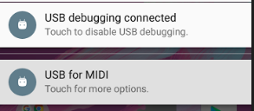

*Note: if you do not see the above notifications on your phone  
 ask your tutor to check your phone is connected properly*

From the home screen of the phone, launch the **MIT AI2 companion application**.

Back in the browser, on the page with the project loaded, select the menu **connect**, then select **USB connection**.

At this point: The project will start running on the phone, and you will be able to test how it is running. Any changes you make to your project in the build environment will automatically update on your phone.

#### No android phone

For anyone without an android phone, you will be asked to use the emulator.

Using this option, you will need to:

Install a startup program onto your computer

More details about setting up the emulator can be found [here](http://appinventor.mit.edu/explore/ai2/setup-emulator.html). Note that when using the emulator, some android features and sensors will not work.

## Deploy

### Source Code

All projects will have some sort of source code which relates to them. In this environment, the source code is represented as an **.aia file**. Source code can be loaded into the build environment and can have changes applied to it. This is important because the **.aia file** for a project can be exported from the build environment and shared among others, which will no doubt be helpful for group work.

To download the source code:  
From the build environment with the project loaded, select the menu option **projects 🡪 Export selected project (.aia) to my computer**

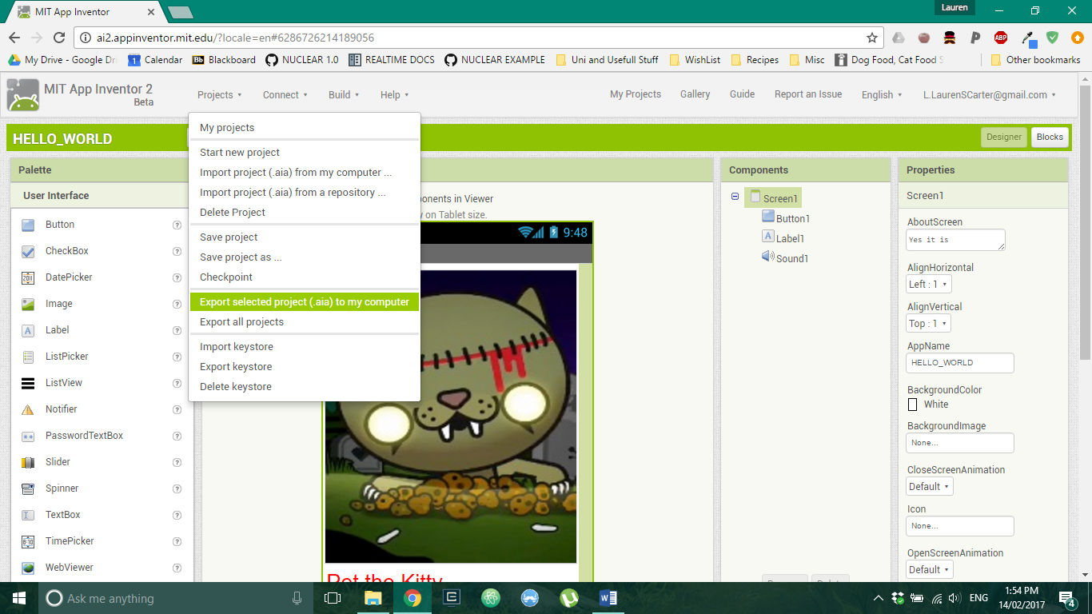

Once you have the **.aia file,** it can be loaded to someone else's project environment, so that they have the option to load the project, and make changes.

To install source code:  
Ensure you have access to an .aia file. From the build environment, select the menu option **projects 🡪 Import project (.aia) from my computer.** Select the file you wish to load.

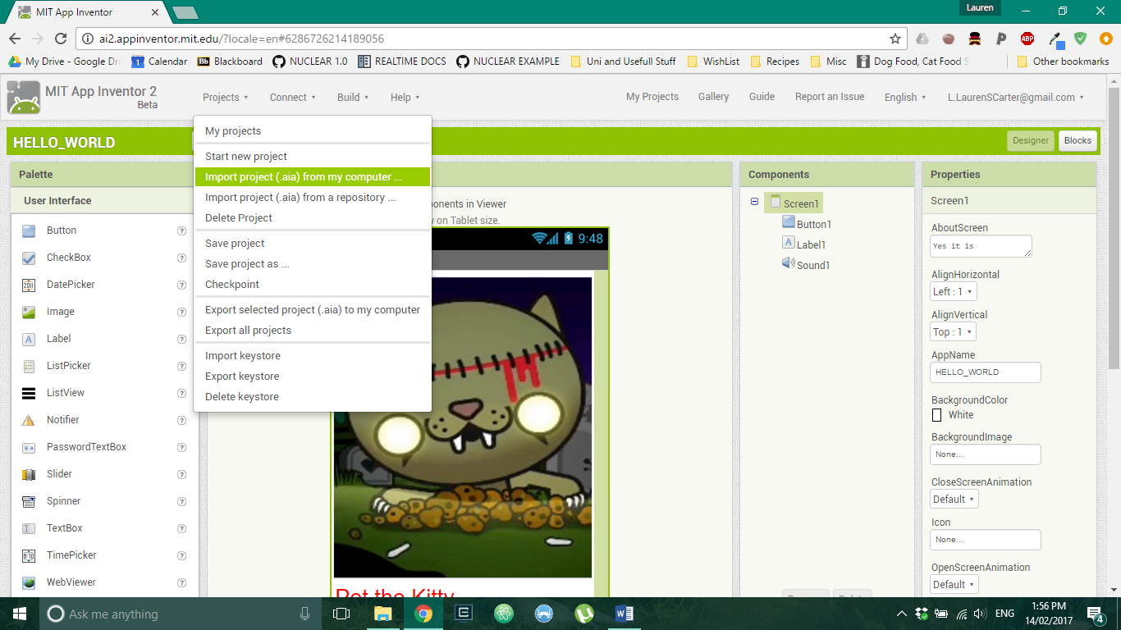

### Build

The app can be built/compiled for distribution and sharing. When an application is built, it will give you an **.apk file** which can be installed onto an android phone. When the application is installed, it no longer requires the use of the **MIT AI2 companion application** to run it.

To build the application:  
From the build environment with the project loaded, select the menu option **build 🡪 App**.

*Note: for sharing a built file, it is easiest to use the second option* ***(save to my computer)*** *then download as an* ***.apk file.***

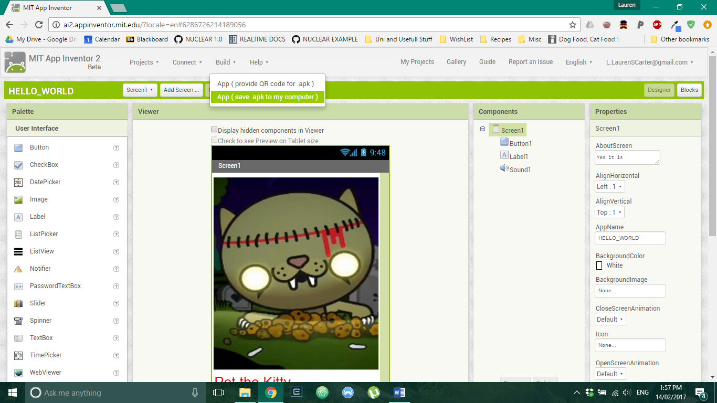

You can save this **.apk** file to a cloud environment (such as google drive) so that it can be accessed then installed on your phone.

#### Install the application

Ensure your phone can install applications from unknown sources. (settings 🡪 security 🡪 check unknown sources 🡪 select okay).

Navigate to the cloud environment where you have saved your **.apk file**.

Open the **.apk file**. The installation process should begin.

*Note that you cannot make changes to an* ***.apk*** *file once it has been made. If you have installed it on your phone, and you wish to make changes to the application, you need to make changes to the source code, rebuild the application, then re-install it on your phone.*

More details about sharing the **.aia** and .**apk** files can be found [here](http://appinventor.mit.edu/explore/ai2/share.html)

More details about side loading can be found [here](http://www.techrepublic.com/blog/smartphones/how-to-side-load-apps-on-your-android-device/)

#### Publish

When you are truly happy with your application, it can be published to the playStore.

Details about publishing your application (including distribution at the playStore) can be found [here](http://appinventor.mit.edu/explore/ai2/google-play.html)